VRF, VLAN and IP addressing provisioning system

Maldonado González Giordan Daniel FIEC - ESPOL
Guayaquil, Ecuador
gdmaldon@espol.edu.ec
Perez Noboa Bryan Alfonso
FIEC - ESPOL
Guayaquil, Ecuador
baperez@espol.edu.ec

Alvarado Cajape Stalin Xavier
FIEC - ESPOL
Guayaquil, Ecuador
staxaalv@espol.edu.ec
Campoverde Rodriguez Ernesto Celin
FIEC - ESPOL
Guayaquil, Ecuador
ercecamp@espol.edu.ec

Abstract— The following article has as purpose to show the implementation of a provisioning system of VRF, VLAN and IP addressing for an Internet Service Provider (ISP), in order to be able to perform these tasks through an application that is easy to manipulate for the user.

Introduction
An autonomous system (AS) is the grouping of IP networks that have their own and independent routes policy. This means that it performs its own traffic management that flows between it and the different Autonomous Systems that are in the network. Each AS has a number that uniquely identifies it among its networks within the Internet, it is like a small Internet, since its role is carried out by a single entity, the same Internet Service Provider (ISP).

theoretical framework

Virtual Local Area Network - VLAN
A Virtual Local Area Network or Virtual LAN is a local area network that groups a set of computers logically and not physically. Indeed, the communication between the different devices in a local area network is governed by the physical architecture. Thanks to virtual networks (VLANs), it is possible to get rid of the limitations of the physical architecture (geographical limitations, address limitations, etc.), since a logical segmentation based on the grouping of equipment according to certain criteria is defined (MAC addresses), port numbers, protocols, etc.).
Various types of VLANs have been defined, according to switching criteria and the level at which it is carried out. Thus, the level 1 VLAN (port-based VLAN) defines a virtual network according to the connection ports of the switch. The level 2 VLAN (VLAN based on the MAC address) defines a virtual network according to the MAC addresses of the stations. This type of VLAN is more flexible than port-based VLAN, since the network is independent of the location of the station.
The VLAN allows to define a new network over the physical network and, therefore, offers several advantages:
- Greater flexibility in the administration and in the changes of the network, since the architecture can be changed using the parameters of the switches
- Increase in security, since the information is encapsulated at an additional level and can be analyzed; a decrease in the transmission of traffic on the network.
VLANs are defined by the IEEE 802.1D, 802.1p, 802.1Q and 802.10 standards.

Virtual routing and forwarding - VRF
Is a technology included in IP network routers (Internet Protocol) that allows multiple instances of a routing table to exist on a router and work simultaneously. This increases functionality by allowing network routes to be segmented without using multiple devices. Since traffic is automatically segregated, VRF also increases network security and can eliminate the need for encryption and authentication. Internet Service Providers (ISPs) often take advantage of VRF to create different virtual private networks (VPNs) for clients, so the technology is also known as VPN routing and forwarding.
VRF acts as a logical router, but while a logical router can include many routing tables, a VRF instance uses only one. Additionally, VRF requires a forwarding table that designates the next hop for each data packet, a list of devices that can be called when sending the packet, and a set of rules and routing protocols that govern the way the packet is handled. These tables avoid traffic since they are being forwarded out of the path of a specific VRF and keep out the traffic that could remain outside the VRF route.

Secure Shell – SSH
Is a remote administration protocol that allows users to control and modify their remote servers over the Internet. The service was created as a secure replacement for the unencrypted Telnet and uses cryptographic techniques to ensure that all communications to and from the remote server happen in an encrypted manner.
It provides a mechanism to authenticate a remote user, transfer entries from the client to the host and retransmit the output back to the client.
The SSH protocol provides the following types of protection:
- After the initial connection, the client can verify that he is connecting to the same server to which he was previously connected.
- The client transmits its authentication information to the server using robust 128-bit encryption.
- All data sent and received during the session is transferred through 128-bit encryption, which makes them extremely difficult to decipher and read.

Project Design

Network Design
The proposed diagram represents the connectivity between a router P and a Provider Edge router (PE, representing a city). There is an OSPF routing protocol between both routers. It should be noted that there may be more than one PE router.

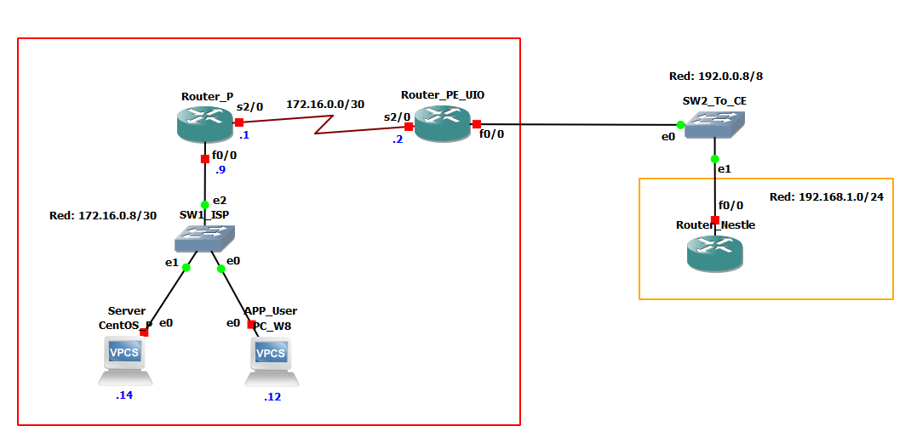Fig. 1 Network

Deployment diagram
This diagram represents our network in a much simpler way, we can observe how the user interacts with the server, the operating system of each device and the interfaces that are interconnected.

Fig. 2 Deployment Diagram

Entity-Relationship Diagram
This diagram represents how each class of the application relates to the database. That is, it is a visual representation of how our information is stored and how it relates to each other.
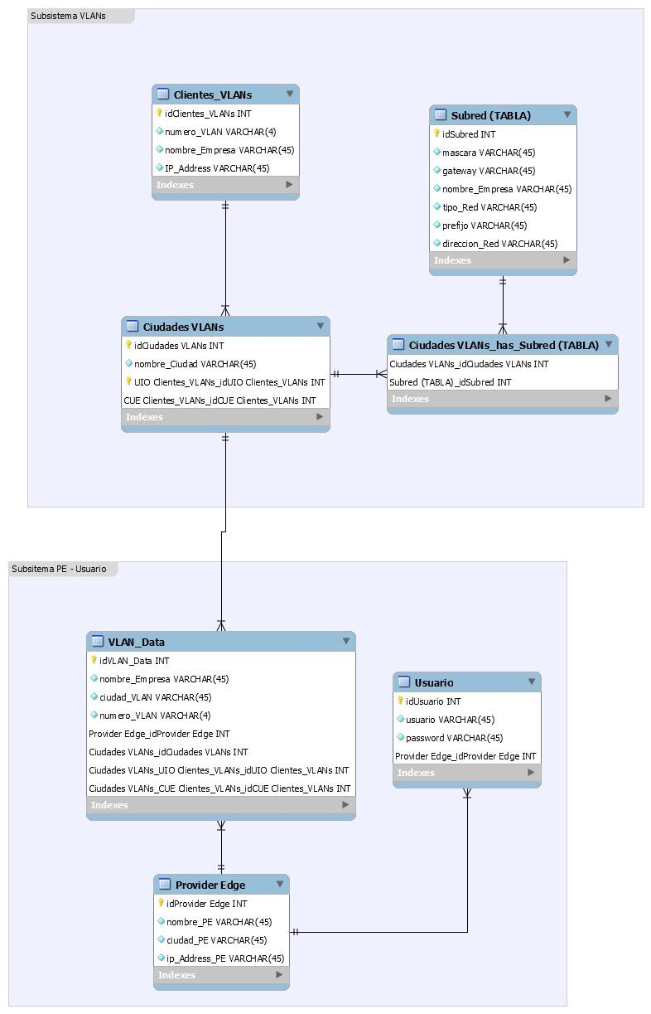
Fig. 3 Entity-Relationship of database

Interfaces
Login window, in which the user enters their data to access the router. It should be noted that this user must be registered in the database.

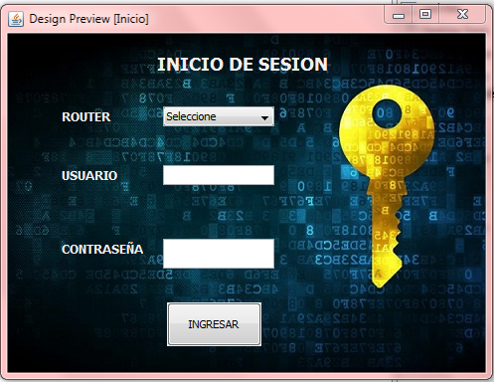
Fig. 4 Login Window

In this new window we have already accessed the router, and we have the options to create VLAN, create, VRF and assign links

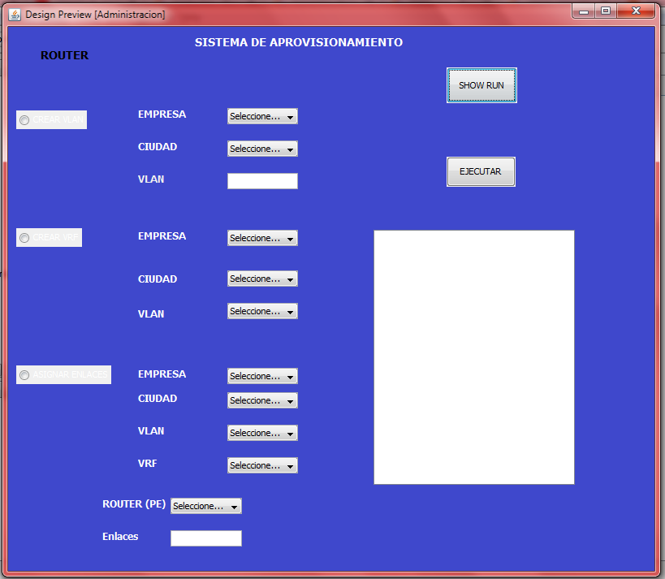Fig. 5 Router Configuration

Results
The results we obtained from the implementation:
- We can create from 1 to 4096 VLANs
- We can create a VRF
- We can assign up to 254 links to a company for each VLAN it has

Conclusions
The SCRUM methodology was of great help to be able to complete the project successfully. This is due to the fact that we work progressively in times established by the planner and therefore, the project progressed in a feasible manner according to what the client requested.

Acknowledgment (Heading 5)
I would like to thank Msig. Collaguazo Adriana for his friendship, effort and perseverance when transmitting his knowledge.

References

- Ravi Kumar CV, Dhanumjayulu C, Bagubali A and Bagadi KP," Architecture for MPLS L3 VPN Deployment in Service Provider Network", Journal of Telecommunications System & Management 2017

- Abid Shahzad and Mureed Hussain," IP Backbone Security: MPLS VPN Technology", International Journal of Future Generation Communication and Networking, Vol.6, No.5 (2013)

- R. Alshammari, P. I. Lichodzijewski, M. Heywood, and A. N. ZincirHeywood, “Classifying ssh encrypted traffic with minimum packet header features using genetic programming,” in Proceedings of the 11th Annual Conference Companion on Genetic and Evolutionary Computation Conference: Late Breaking Papers. ACM, 2009, pp. 2539–2546.

